
Meridian M2XXX Series Terminals
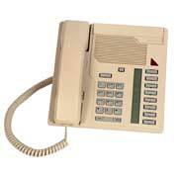
M2008 Basic Business Telephone
The M2008 is a standard multi-line business telephone. Eight programmable feature keys provide quick access to lines and features. The M2008HF model includes a built-in speakerphone.
Key Features
- Multi-line telephone
- 8 programmable line/feature keys
- Built-in handsfree (M2008HF)
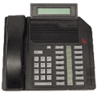
M2616D Business Telephone
The M2616D is designed for people who require multiple lines and quick access to a broad range of features. Fully handsfree with a built-in 2-line x 24 character alphanumeric display that provides vital incoming and outgoing call information. By adding one or two 22-button Key Expansion Modules, the basic complement of 16 programmable keys can be increased to 38 or 60 keys for additional lines or access to powerful Meridian 1 features.
Key Features:
- 16 programmable line/feature keys
- Dual handset/headsets jacks
- Compatible with Key Expansion Module(s) to provide a total of 60 line/feature keys

M2216D ACD Telephone
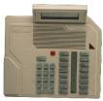
Key Features:
The M2216 ACD digital telephone is designed for the specialised requirements of agents and supervisors in the call centre environment. The M2216ACD includes, standard, a built-in 2-line x 24 character alphanumeric display that provides vital incoming call information required by agents for customised greetings. Dual headset jacks enable supervisors to train and monitor agents' performance while they are talking with callers.
Key Features:
- 16 programmable line/feature keys
- Dual handset/headsets jacks
- Built-in Display for call related statistics
- Compatible with Key Expansion Module(s) to provide a total of 60 line/feature keys.
Colours available: Chameleon ash, Charcoal & Dolphin grey.

Legacy Telecom Ltd

Telephone. 08700500238 Fax. 08700500239. Email sales@legacytelecom.co.uk

